Appendix

Note to Instructors

Note to the Student and Instructor: Although there is a lot of information in the following slides, most of them have color pictures of the apparatus, screen shots of the computer data acquisition, diagrams, spreadsheet tables, and graphs. We have tried to reduce the amount of text only information and make it so students (and instructors) have a more informative and pleasant learning experience than in previous versions of this experiment.

The actual amount of data taking and measurements you have to do for this lab has been greatly reduced from previous years in order for students to be able to complete the entire lab, including report, in a 2 hour and 50 minute lab period. It involves obtaining 6 data points for a single spring of one color for static measurements, and 9 data points for the same color springs in different configurations using the dynamic method. A total of 15 data points involving 4 different experimental situations.

Due to a lack of standardized data taking procedures and poor computer data acquisition file design in years past, the vast majority of students got very poor quality data, often with gross errors associated with incorrect computer data acquisition procedures associated with the use of the photogates and software. An extensive, step by step, standardized procedure has been developed, which if followed, will greatly improve the quality and accuracy of the results and speed up the data taking.

An improved Logger Pro .cmbl data acquisition file has been developed that eliminates time consuming and tedious manual counting and averaging of oscillation periods that had to be done previously, eliminates previous frequent factor of 2 period measurement errors, and also gives a quick display of all the periods to check for uniformity and to immediately see if the data is contaminated by spurious lateral (swinging) oscillations.

Similarly for the data analysis. In previous years, students had to waste precious lab time trying to come up with an Excel spreadsheet to perform calculations and plot graphs. The majority of students are not familiar with the use of a computer spreadsheet, like Excel, which led to many errors associated with not properly selecting columns to make plots or performing elementary calculations correctly. Even for those few students that have some experience with Excel, this required too much time just to make the spreadsheet. The vast majority of students got results in gross error, and did not finish the dynamic measurement and calculations of springs in parallel or series.

To make matters worse, the lab writeup previously assumed the ideal form of Hooke’s law, which does not apply to extension springs, thus giving results in further error. The treatment has been corrected to use the modified Hooke’s law, which includes the initial spring tension present in all real extension springs.

Therefore a standardized spreadsheet file has been developed to perform all calculations, least square fitting procedures, and automatic graph plotting, all you have to do is take the measurements carefully and enter your data points in the correct cells for each Excel tab, and then copy the tables of least square fit values, results, and graphs into your lab reports.

This greatly speeds up the lab and allows students to focus on the physics of the situation and spend some time writing up a thoughtful discussion of a few questions, results, and a quantitative conclusion/summary.

There are a few questions about the experiment at the end of this presentation on the last slide which should be answered as part of your lab report. The student should read and think about the answers to these questions before coming to lab

Miscellaneous additional information and references

Equivalent mass of a coil spring

Lawrence Ruby

Phys. Teach. 38, 140 (2000); 10.1119/1.880475

View online: http://dx.doi.org/10.1119/1.880475

On the spring constant of a closecoiled helical spring

P. Mohazzabi and J. P. McCrickard

American Journal of Physics 57, 639 (1989); doi: 10.1119/1.15962 View online: http://dx.doi.org/10.1119/1.15962

E.E. Galloni and M. Kohen, “Influence of the mass of the spring on its static and dynamic effects,” Am. J.

Phys. 47, 1076–1078 (Dec. 1979)

Previous coil springs

Phys. Teach. 38, 259 (2000); 10.1119/1.880523

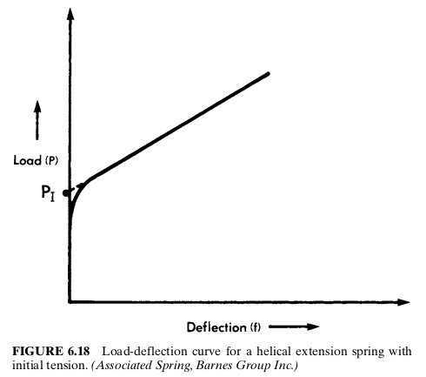

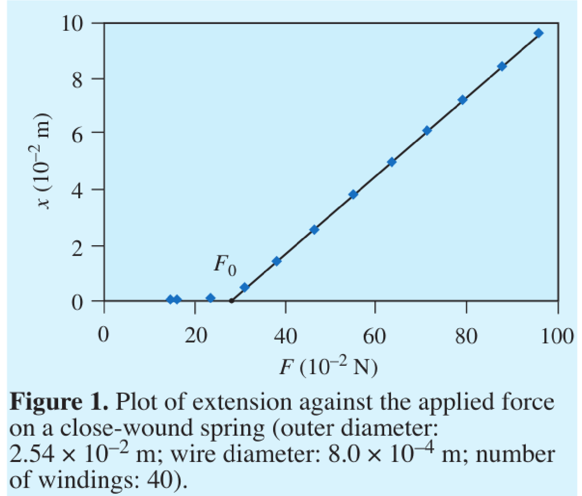

According to Shigley and Mischke [3] the initial force of a spring is created during the winding process by twisting the wire as it is wound onto a mandrel. When the spring is removed from the mandrel, the initial force is locked in because the close-wound spring cannot get any shorter. It is of interest to investigate the relation between the initial force and the stiffness of the spring.

Shigley J E and Mischke C R 1989 Mechanical Engineering Design 5th edn (New York: McGraw-Hill) pp 415–6, p 418

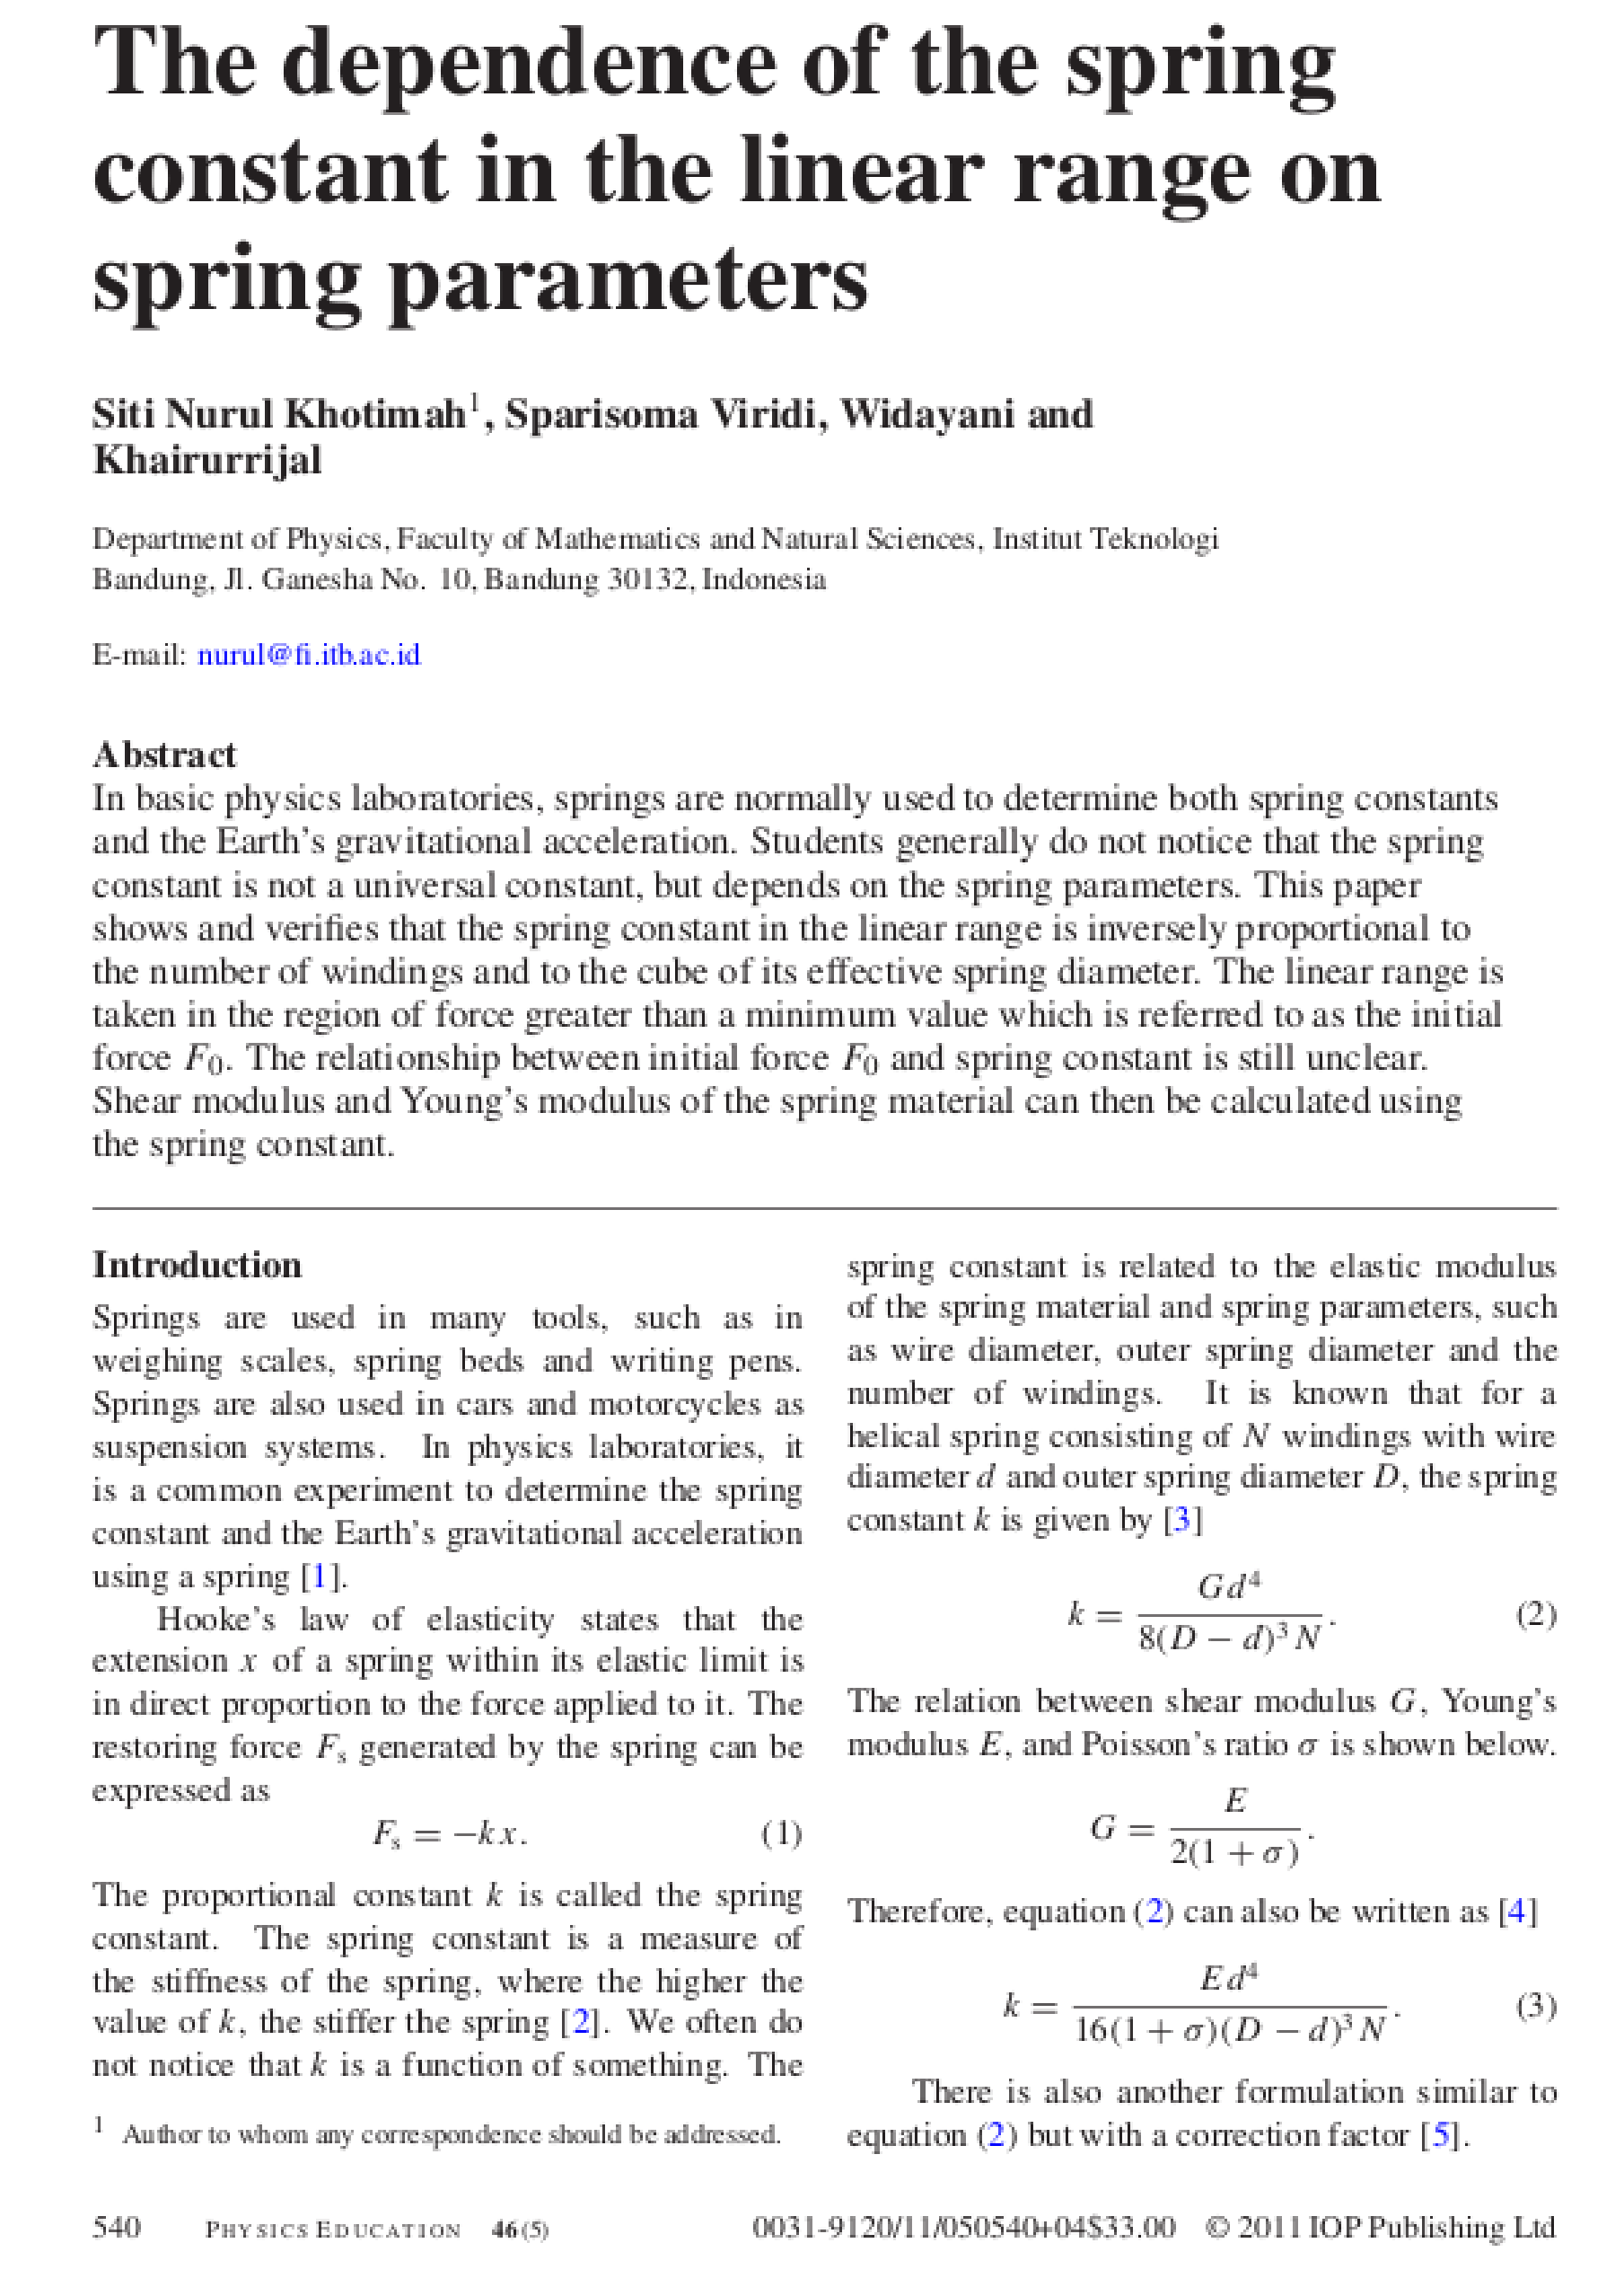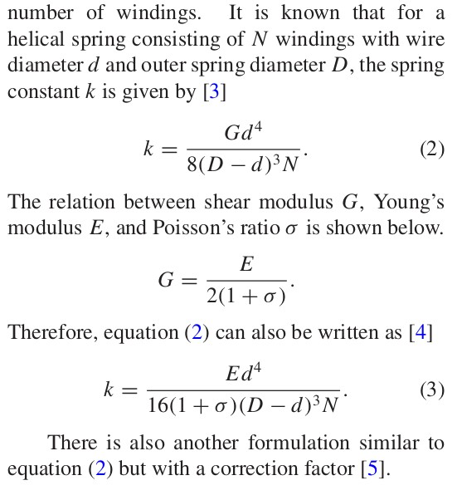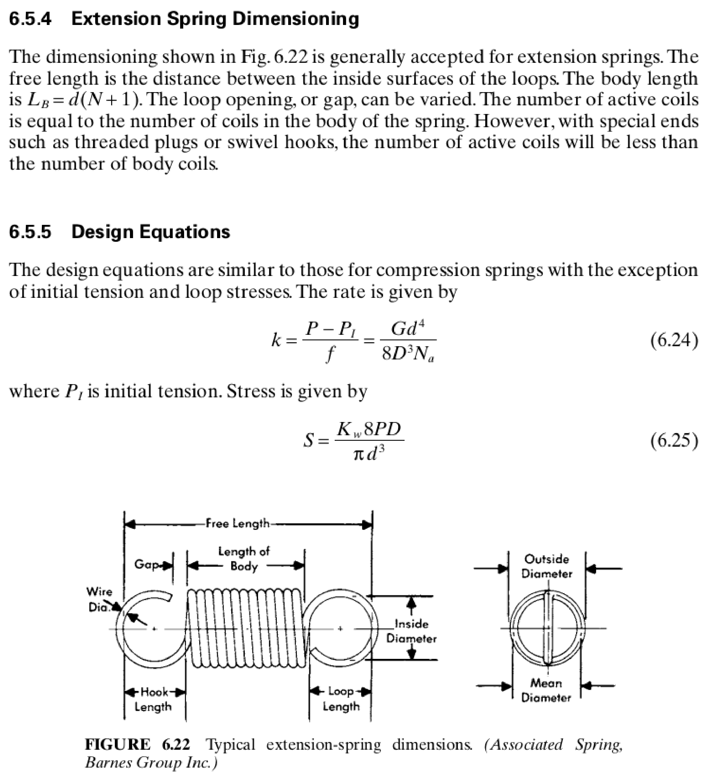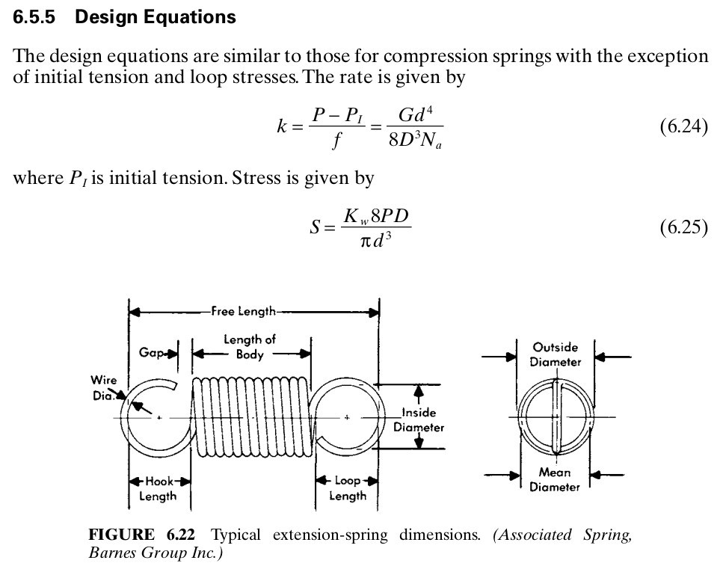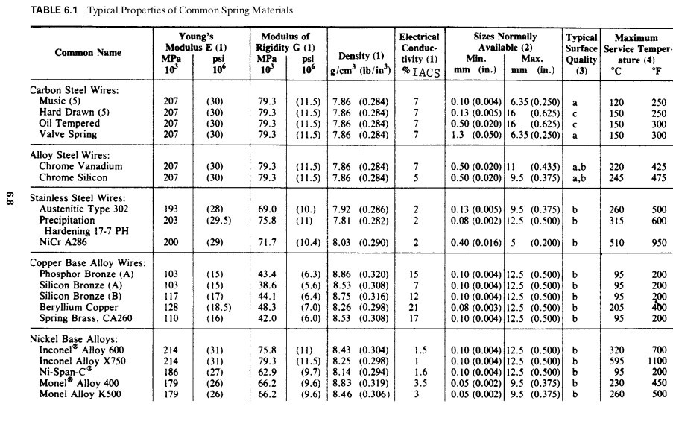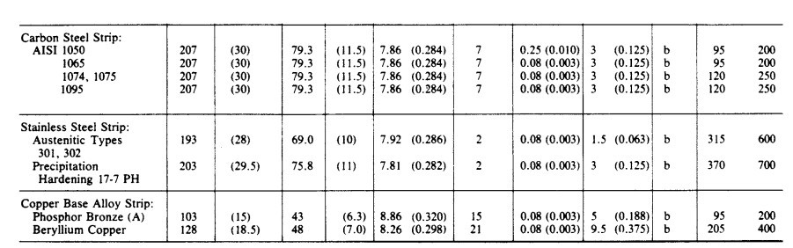

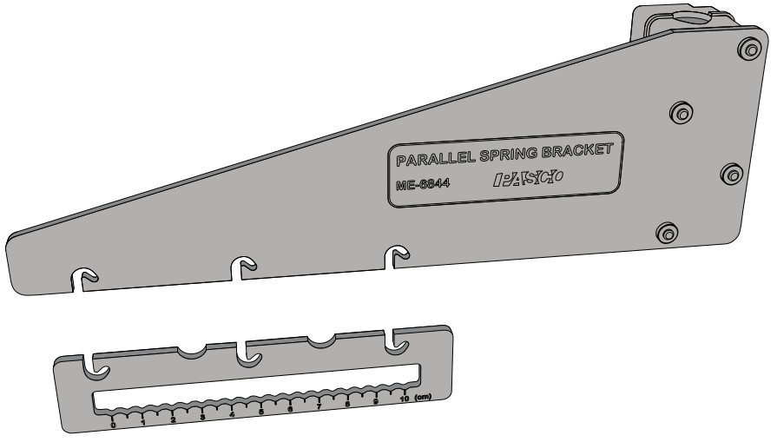

Parallel Hook bar (lower)

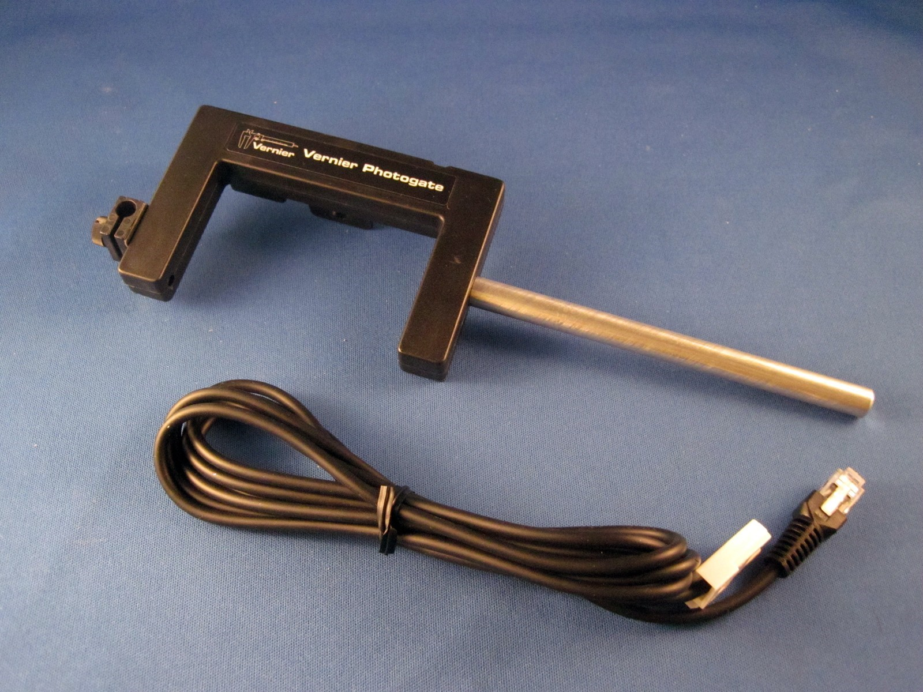

Photogate used in the experiment. Bottom side shown compared to other slides.

<https://www.vernier.com/manuals/vpg-btd/>

**Pulse Timing**



In this mode, a measurement from when a photogate gets blocked to when it gets blocked again will be recorded.

**Pendulum Timing**



Pendulum Timing mode uses a photogate connected to an interface. The timing begins when the photogate is first interrupted. The timing continues until the photogate is interrupted twice more, so that you get the time for a complete swing of a pendulum or other oscillating object.

For a good discussion of these issues, see “Photogates: An instrument evaluation,” Eugene P. Mosca and John P. Ertel, Am. J. Phys. 57 (9), 840–844 (1989).

A more comprehensive tutorial can be found in the following documents:

Logger Pro Introduction to the Vernier Photogate

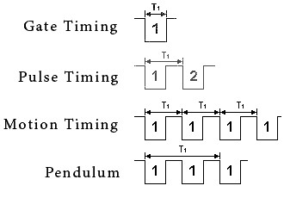

Pulse Timing method is being used in the Logger Pro file Spring_Timer.cmbl. Avoids problems with 2 triggers per period required in the Pendulum method.

Note y is positive up on this

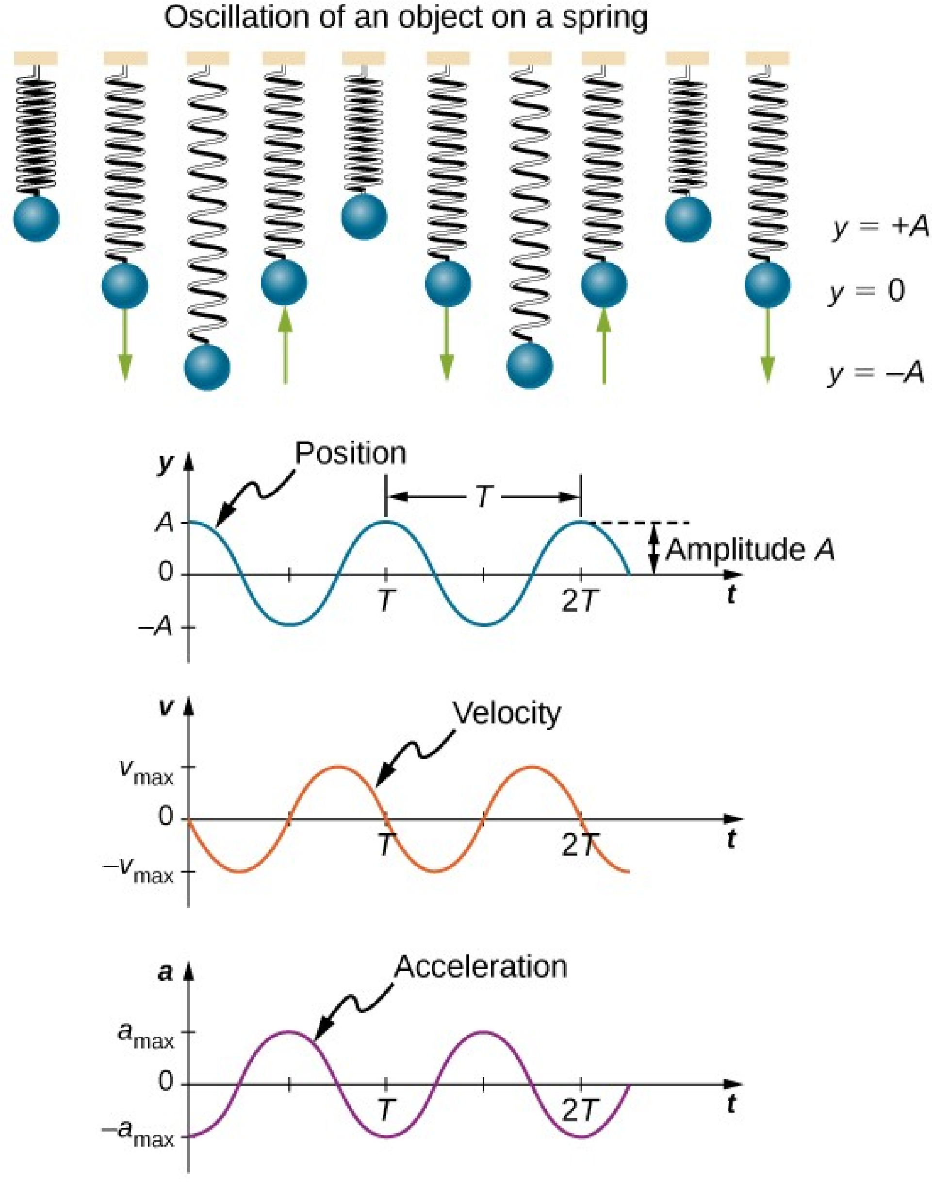

Diagram. y positive down is

The convention chosen in this Experiment. The spring only extends in one direction, and that is down here.

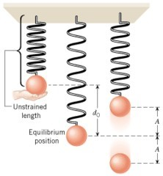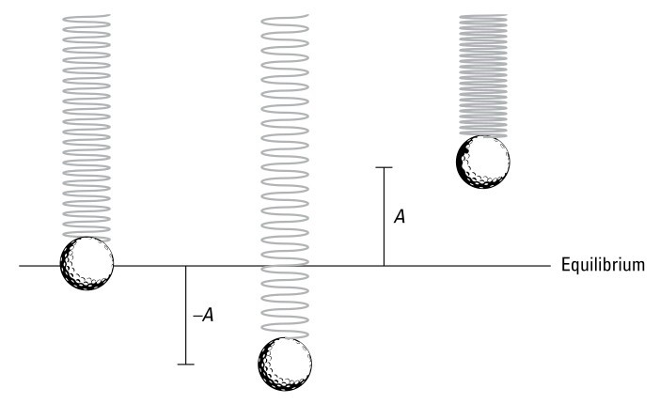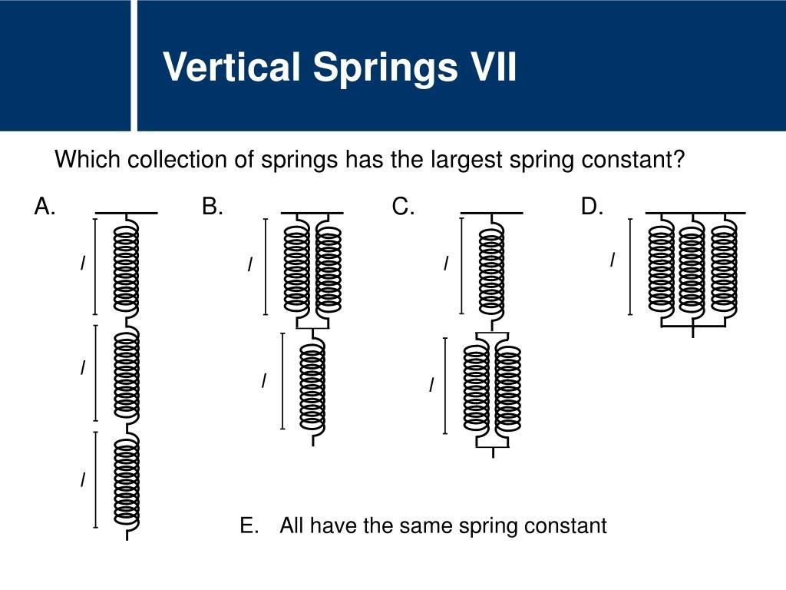

https://image1.slideserve.com/3406680/question-title7-l.jp

[g](https://image1.slideserve.com/3406680/question-title7-l.jpg)