# Lab 4: Projectile Motion

## What You Need To Know:

### The Physics

So far in lab you’ve dealt with an object moving horizontally or an object moving vertically. Now you are going to examine an object that is moving along both axes at the same time. This is called *projectile motion*.

$$x=x_{0}+v_{0_{x} } t+\frac{1}{2} a_{x} t^{2}$$

$$v=v_{0_{x}}+a_{x} t$$

$$v^{2}=v_{0_{x}}^{2}+2a(x-x_{0} )$$

(1)

Projectile motion is one of the concepts in mechanics that students have the most trouble with. The ideas, however, are no different from the ones you’ve been dealing with already. The key to projectile motion is to analyze the motion one axis at a time (either x-axis or y-axis). You are still going to be using the linear motion equations that you’ve been using in class but now you have to be clear on whether you are using horizontal information or vertical information. The most common error with students is that they use horizontal information for vertical information and vice-versa.

### Summary

This lab will involve three steps.

1. For a horizontal launch, measure the distance the ball launches and use it to find the initial velocity out of the launcher’s barrel using kinematics.
2. Use a photogate device to measure the speed out of the barrel and compare it to what you found in part 1.
3. Use kinematics to predict a landing location for the projectile launch, and test that prediction.

### The Equipment

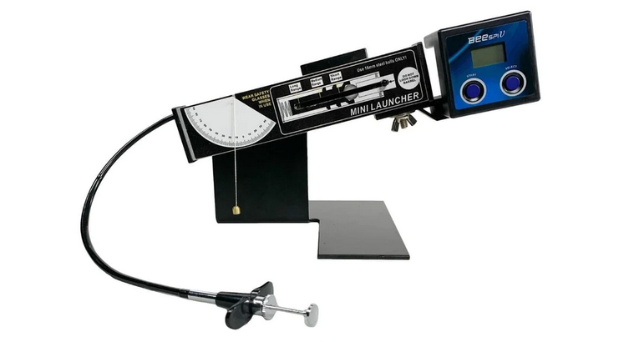

1: Plumb Bob

2: Side Loading Spring

3: Plunger Launch Trigger

4: Barrel

5: Beespiv

Today you’ll be working with the above shown mini projectile launcher with detachable speed measurement device.

The important parts you need to be aware of are:

1. Plumb Bob: Reference this to determine the angle that the barrel is set at.
2. Side Loading Spring: SHOULD NEVER BE LOADED PAST “SHORT RANGE”. There is likely tape on the launcher to prevent over loading.
3. Plunger launch trigger. Push this to launch the ball once loaded.
4. Barrel. Never look down the barrel when it is loaded for good safety practice.
5. Beespiv measurement tool. It’s the box on the end that slides in and out of the plastic holder attached to the bottom of the barrel..

## What You Need To Do:

### Part 1: Horizontal Launch to Find Initial Speed.

In this part you’ll be practicing using kinematics in a horizontal launch. Like the balls thrown horizontally off the top of buildings in your lecture.

1. If the Beespiv device is on the launcher remove it and set it safely aside.
2. Rotate the barrel up to 90 degrees and load the ball into the launcher.
3. Pull the side loader back to short range while still rotated up.
4. Place the meter stick at the back edge of the table to help prevent the ball’s escape.
5. Rotate the barrel down and set the launch angle to zero degrees and do a test launch of the ball to see where it will land.

You must do this procedure of rotating every time you load the ball going forward, or you’ll see a decrease in your velocities.

1. Place graphing paper on the desk, then place a piece of carbon paper on top.
   1. This way where the ball lands will be clearly marked on the graph paper.
   2. DO NOT TAPE THE CARBON PAPER TO ANYTHING.
   3. When taking measurements one student safely hold down the graph paper and be ready to catch the ball after it bounces.

ONLY LAUNCH FROM SHORT RANGE SETTING AND BE SURE THE AREA IN DIRECTLY IN FRONT OF THE BARREL IS CLEAR AT ALL TIMES BEFORE LAUNCHING.

1. Open the excel sheet that accompanies this lab.
   1. The cells you need to edit are unprotected. You can unprotect the sheet if you’d like, there is no password, but try not to edit equation cells that were entered for you.
   2. Locate the part 1 table. You’ll fill it out in the next step.
2. Take a measurement of height h and launch distance x:
   1. Rotate the barrel upward and load the ball to the short range setting.
   2. Rotate the barrel down and align the hanging plumb bob with zero degrees.
   3. Prepare to catch the ball.
   4. Launch the ball.
   5. Without moving the graph paper, remove the carbon paper and measure from the center of the launch end of the barrel to the center of the circle left on the carbon paper. Record this as $x.$
   6. Measure the distance from the table to the bottom of the launch end of the barrel (the bottom of the loaded ball) where the ball exits the barrel. Record this as $h$.
3. Repeat the previous step E) 2 more times so you have three measurements of h and x.
4. For each of these values use the kinematic equations to calculate the speed of the ball launch.
   1. This is done for you in the excel sheet Calculated cells. You can click the cell to see the equation found in question 1 in excel form.
   2. First using the kinematic equations (1) in the y direction you can find the time of flight t.
   3. Then using the time of flight you can use the kinematic equations (1) in the x direction to find the initial velocity in the x direction.

Question 1: (Optional to Instructor Choice)

Work through steps J)b. and J)c. to find the following equation:

$$v_{0_{x}}=x*\sqrt{\frac{g}{2y}}$$

This equation is entered in the calculated column of the excel sheet.

1. Calculate the average of those speeds and record it.

|  |
| --- |
| $${v_{0}}_{x}$$ |
|  |

You’ve now successfully used kinematics to find the speed of a projectile out of a barrel oriented horizontally. Could apply this to a cannonball from a cannon, a thrown or kicked ball in any sport, and more as long as the initial launch is pointed perfectly horizontally, which isn’t very common in any of those examples...

### Part 2: Comparison with Velocity Measurement, Device Test

In this part you’ll take the experiment you ran in part 1 and use it to check the quality of a measurement tool that should do the same thing.

1. Attach the Beespiv velocity measurement device by sliding it into the holder sticking out the bottom of the launcher.
2. Press the start button on the launcher and verify that it says “m/s” in the bottom right corner. When this is flashing that means its ready to take data.

This device collects data by measuring the time it takes to break two beams inside that are a known distance apart, carefully give it a test with your finger by passing it through the two beams and watching it take the speed of your fingers pass.

1. Take a speed measurement using the Beespiv:
2. Tilt the barrel up and then load the launcher to the first setting,
3. Tilt the barrel back down to 0 degrees as before.
4. Press start on the Beespiv, the m/s should be flashing.
5. Prepare to catch the ball.
6. Launch. Note down the speed you get.

Question 2:

Calculate a % error between the value and the value you calculated in part 1. Discuss possible causes of any error.

Question 3:

Which value do you have more confidence in and why? The part 1 average value or the part 2 equipment measured value. What could you do to improve that confidence?

1. Change the angle of the launch then repeat step C for different angles until you have 4 more values, all at different angles.

Question 4:

Does the angle of the launch have much effect on the speed measurement of the device? What might cause disagreement?

You’ve now tested the quality of a measurement device. Note in practice you’d want to control your experiment much more than you did here before you send the error to the manufacturer and complain.

### Part 3: Angled Launch

In this final part you’ll use your predicted speed from part 1 to estimate the landing location of an angled launch at that same speed. Assuming the launcher fires at nearly the same speed as in horizontal launches (Your answer to question 3 might cause concern here, or it might not).

1. Remove the Beespiv speed measuring device. Press and hold both buttons until it turns off, then set it safely aside.
2. Pick a new angle between 10 and 70 degrees as your launch angle $θ$.
3. Load your ball into the launcher as before.
4. Set your launcher to that angle and measure the new height from the table to the center of the barrel opening, this is the new height h.
5. Record both of these values in the excel sheet and you should see an expected landing angle calculated.

|  |  |  |
| --- | --- | --- |
| $$θ (°)$$ | $$h$$ | $$x (m)$$ |
|  |  |  |

The landing location is calculated using the kinematic equations:

* 1. You’ll have to first find the time of flight with the vertical equation. (And the quadratic equation)
  2. Then find the horizontal distance with the horizontal equation.
  3. This is done for you in the excel sheet.

Question 5: (Optional by Instructor Choice)

Show where the equations below come from.

$$t=\frac{v_{0}\sin\left(θ\right)+\sqrt{{\left(v_{0}\sin\left(θ\right)\right)}^{2}+2gh}}{g}, x_{prediction}=v_{0}\cos\left(θ\right)*t$$

1. Measure to where this expected landing is and put the graphing paper centered at that location.
2. Your ball should already be loaded and ready to go, just be ready to catch it.
3. Launch and measure the final landing location distance $x_{measured}$ trial 1.
4. Repeat this launch two more times so you have 3 trials of distance measurement for the same height and angle.
5. Calculate a % difference between these two values $x_{measured}$, and $x_{prediction}$.

Question 6:

What may have caused the deviation (no matter how small) between your predicted and measured distance values? (Be sure to consider Question 3).

Question 7:

Would your prediction have been more/less accurate if you used the speed from the Beespiv device in part 2? Explain.

AG 2023